- Rename News menu to 7 CPC Concordance
- Renamed “News” menu item on the left to “7 CPC Concordance”. Clicking on the menu should display the suggested table from the website “Pensioners Portal G of I: Circulars” with links as shown below.
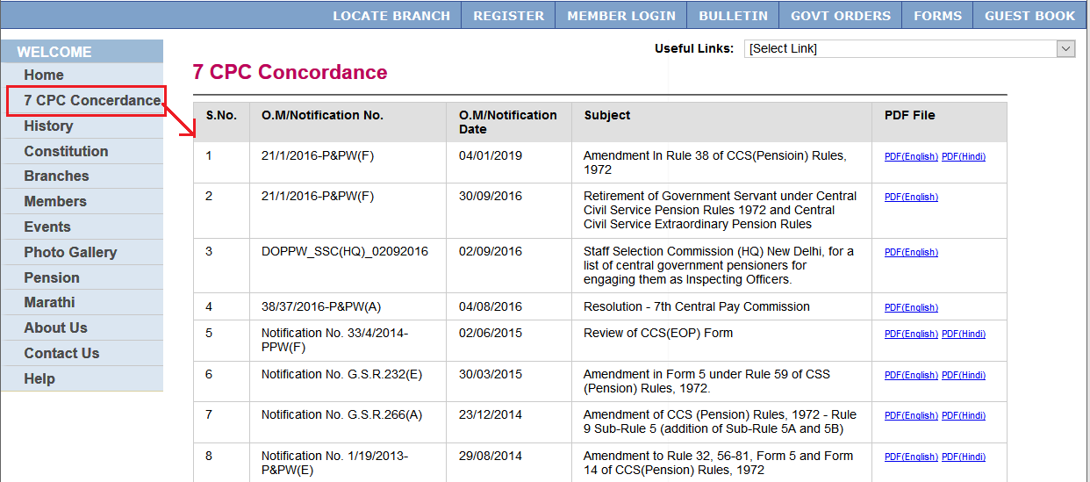
Observations:
A: ‘New’ is replace as ‘7 CPC Concerdance’ It should be ‘7 CPC Concordance’ Spelling mistake.
- Admin Section: Government Order Section
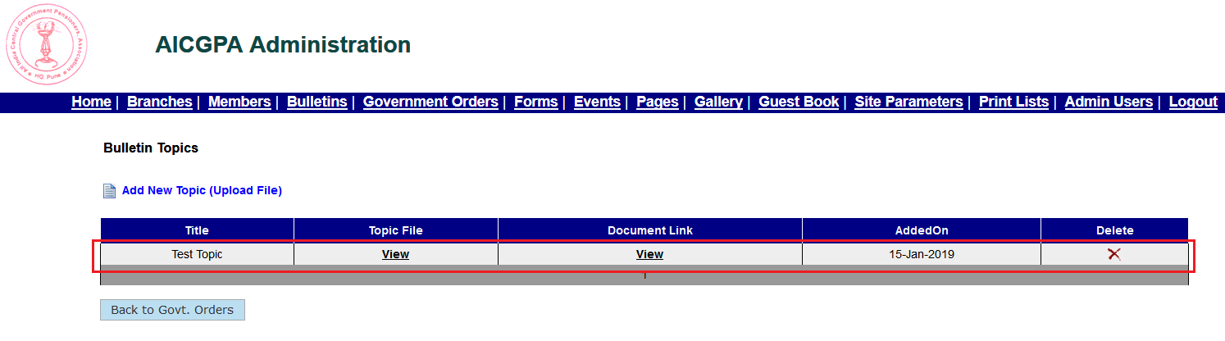

B: Here the column Name and view are showing the same message. When clicked on Document View, error message 404 displays.

- Next, go to main website “http://www.aicgpa.org” and click on “GOVT ORDERS” menu item on the top menu list as shown below. Further, click on the “QE-July - april” government order like to view the topic we just added from admin screen.

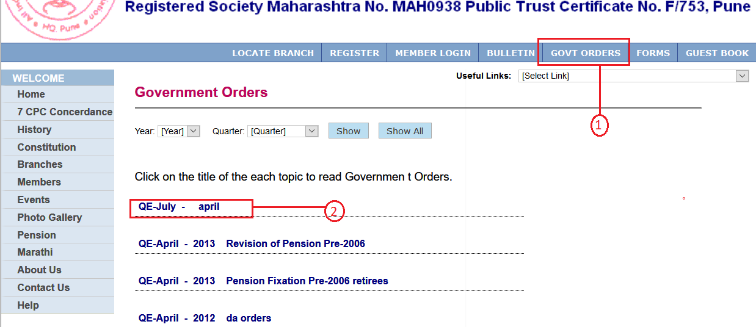

- Clicking on “QE-July - april” link above will display below page listing all topics associated with that government orders. In the list you can also see new column “Document Link” appears.

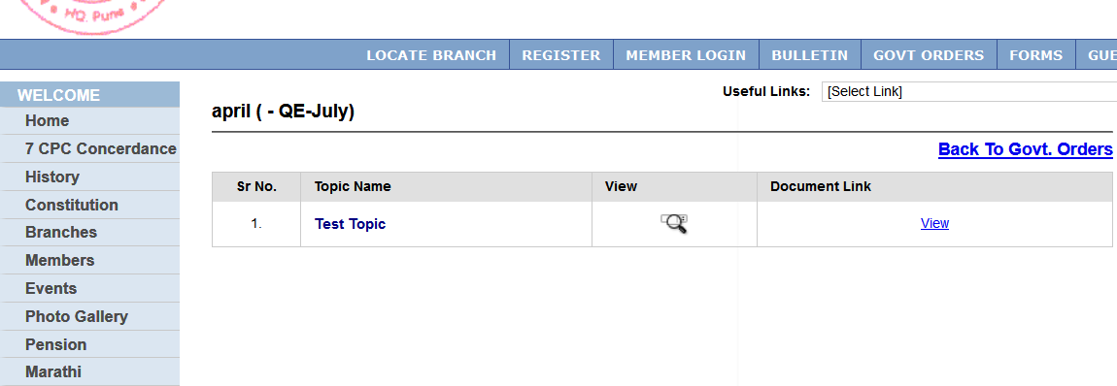

C: Added test and test1. Above view and document link it is showing the error 404.

- Admin Section: Login for Branch Secretary
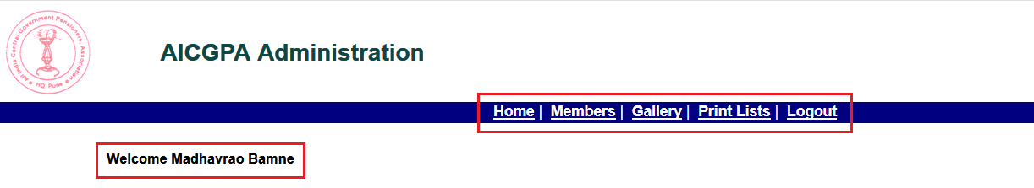
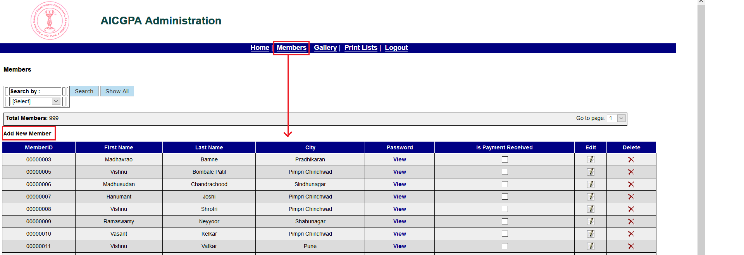
Mr bamane name was deleted as user and created again successfully.
Added a new member ‘pimpri’ successfully.
While searching by name, search fetched the data of ‘Pimpri’
On searching the by registration number search failed.

Adding new member:
For the Use at Brach level, the user creation is provided.
User created.
Add member is working.
Add gallery is working.
Print list.
List is displayed. But to view , error message ‘Server error in ‘/’ application ‘
.

